**INDIVIDUAL FINAL PROJECT**

**Table of Contents**

Introduction 3

Portfolio Overview 3

Webpage Design and Structure 4

GitHub Repository Structure 6

Tools and Technologies Used 7

Challenges and Problem Solving 8

Reflection on Strengths and Weaknesses 9

Future Improvements 10

Conclusion 11

Reference Lists 12

# Introduction

***Purpose of the Portfolio***

A personal computer science portfolio was created as a strategic way to demonstrate technical ability, project experience, and identity as a professional. The portfolio was created in relation to a opportunity for a working student position, to present relevant ability and accomplishments in a tidy and simple structure, that was readily available to others.

***Career Relevance***

With the competitive technology industry today, an online portfolio can only help along the career path. As professional social networking becomes more popular, it is useful for potential employers a diverse collection of the applicants qualifications, programming ability, and project experience. Additionally, it encompasses and expands on a CV to demonstrate initiative, creativity, and knowledge of web development.

***Portfolio Components***

The portfolio contains a number of components: a professional CV which was generated with LaTeX, descriptions of educational and professional experiences, highlights of technical skill, and hosted web content—all deployed with GitHub Pages. The site is written in HTML and CSS with a warm color scheme and simple navigation links to content.

***Purpose of the Report***

The purpose of this report is to illustrate the design process, original implementation, structure and contents of the portfolio. It can describe the tools, design decisions, challenges, and future improvements planned for continually evolving the portfolio.

# Portfolio Overview

***Website Description***

The Harpreet Singh portfolio website is a professional architected site, which is visually pleasing and developed to promote his computer science education. The site was created with HTML and CSS, and has adopted the minimalistic style, as the color scheme has involved warm yellow and light orange colors reminding creativity and professionalism at the same time. It is deployed on the GitHub Pages, so the live site and the source code are publicly available at the corresponding GitHub repository.

The portfolio itself is entirely static and is deliberate made lightweight to load and access on different devices quickly (Gauthier, 2020). It has been made without a space of profile photo to stick on the pure text presentation which can lay stress on the contents and clarity rather than looks.

***Key-Website-Sections***

The site has been subdivided into five primary areas that are arranged into an intuitive navigation top bar that remains in the same position:

* About: This division talks about Harpreet Singh being a zealous student of computer science. It gives a brief of his interest, attitude towards learning, and the problem solving using technologies.
* Education: A brief history of Harpreet with respect to his education with reference to his undergraduate course in GISMA university of applied sciences and his previous education in India.
* Work History: This part brings out that he works at Schnitzery in Berlin where he assists in operations, staff co-ordination, and the smooth flow of work.
* Skills: Organised in a responsive grid structure, technical skills (e.g., Python, HTML/CSS), tools language proficiency and soft skills are placed in separate categories.
* Contact: In this area, there is a necessary contact information such as email, GitHub, and LinkedIn to make it easy to handle by any possible employer or future work colleague interested in contacting them.

***Inclusion of LaTeX CV and GitHub Integration***

A well-made CV using LaTeX can be found on the site and is available for download in PDF format. The. text and. pdf files of the CV, along with the full source code of the website, are hosted on GitHub. To ensure transparency, facilitate version tracking, and demonstrate good use of version control methods, the portfolio now has links to the GitHub repository.

# Webpage Design and Structure

***Design Principles***

The portfolio incorporates key elements from the discipline of web design that embody clarity, minimalism, and accessibility. The portfolio is designed in such a in order to provide a professional layout that is devoid of distractions which allows readers to focus on textual content. The clean design is consistent with the logical manner of thinking that is expected in computer science. The design is focused on quick load times, simplified layout, and easy reference of information (Gaver and Boucher, 2024).

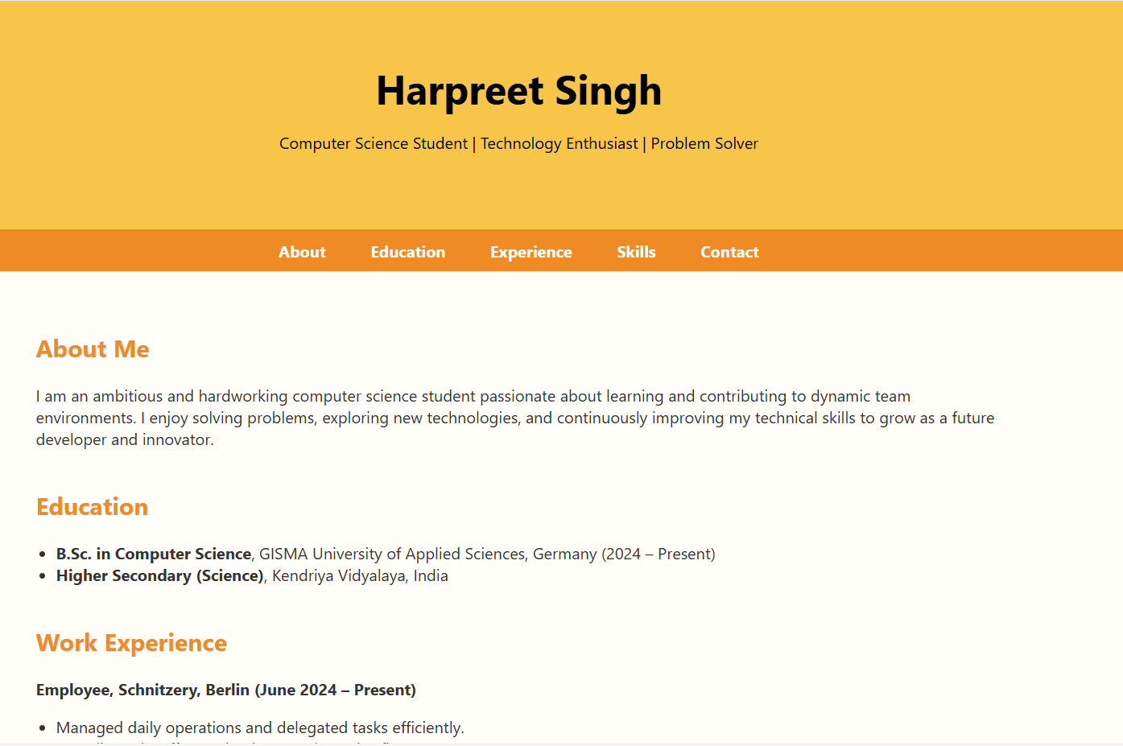

**Figure 1: Portfolio webpage**

**(**Source: Acquired from VS-Code**)**

***Color-Palette:***

The color palette is a warm, professional combination of yellow and light orange to provide an attractive nature while allowing readability. Yellow has meanings of optimism and creativity as a color and light orange is associated with energy and engagement. Combined, this color palette creates a positive experience without redundancy to the viewer which is important to keep the site approachable and friendly.

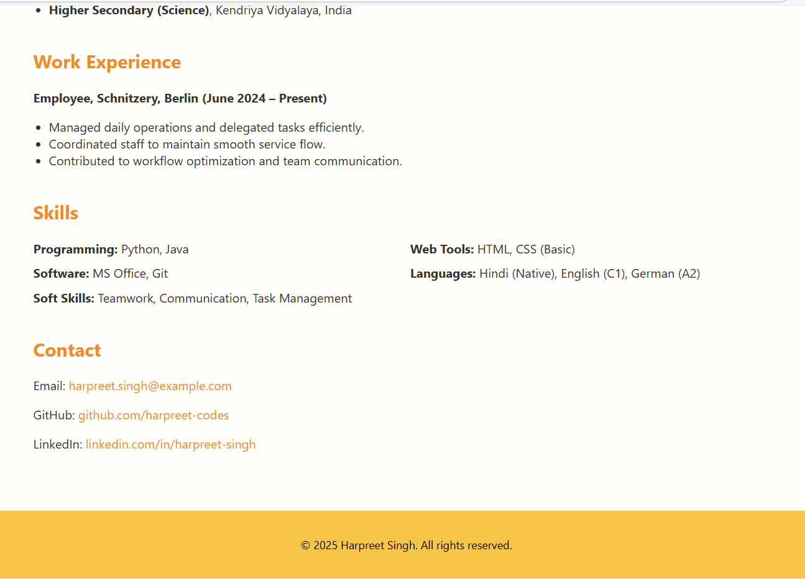

**Figure 2: Portfolio webpage**

**(**Source: Acquired from VS-Code**)**

***Page Structure***

The site is structured using a conventional layout structure:

Header: the candidates name and tagline.

Navigation Bar: fixed at the top so you can smoothly navigate between sections.

Main Content: hosting five sections-About, Education, Work Experience, Skills, and Contact.

Footer: includes copyright information.

This basic structure provides consistent format across devices and makes for easier content flow for viewers.

***Navigation and User Experience***

A navigation bar allows users to quickly access each section of the site, making the experience more enjoyable and minimizing excessive scrolling. All sections are ordered logically, starting at the personal introduction and proceeding until contact information is reached, which aligns with how a person typically reads a resume.

***Responsive and Justified Layout***

Even though the design is static, the layout is responsive enough to accommodate standard screen sizes with a centered container and CSS grid layout for the skills section. This layout is structured enough to be non-interactive and simple, functional and suitable for presenting static content like a CV and work history.

***Suitability for a CS Portfolio***

This layout works well for a computer science portfolio because it showcases technical content while showing basic skills as a front-end developer, and presents the candidate's profile in a clean, modern way without unnecessary fluff (Kuo *et al.,* 2022).

# GitHub Repository Structure

The GitHub repository created by Harpreet Singh is the central repository of the portfolio website and files. There are a few important parts of the repository: index.html: the main HTML file, which contains the base structure and content of the portfolio website. style.css: the stylesheet that dictates the look and responsive layout on the website. cv.tex: the LaTeX source file to produce the professional CV. cv.pdf: the compiled document of the CV, which is available to the users for download. README.md: the markdown file that describes the project, installation direction, and other links.

***Version Control and Deployment***

Git was utilized during the development process to monitor changes, manage versions, and to have a backup of the file. Each commit recorded certain development milestones that made it easier to rollback and track progress. The README.md file is helpful as it guides visitors to the repository, and it also provides context as to how this README was developed. The website was also able to be deployed via GitHub via GitHub Pages. This provides free hosting and allows for site updates to occur automatically once pushing to the main branch.

# Tools and Technologies Used

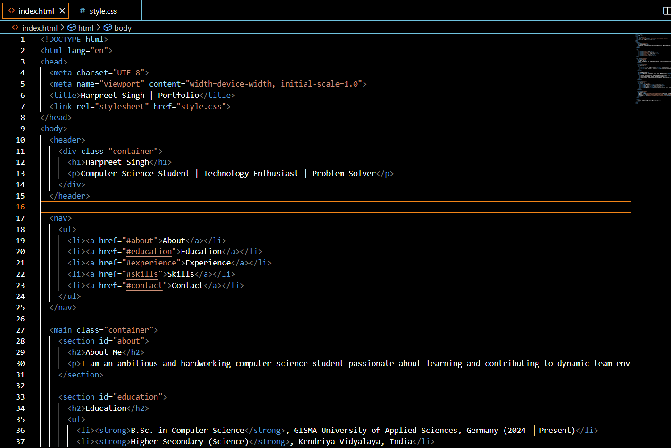

**Figure 3: Html code**

**(**Source: Acquired from VS-Code**)**

* ***CSS and HTML:*** HTML and CSS were used in building the fundamental framework and appearance design of the portfolio site. The semantic layout of the site was developed with the help of HTML, and the presentation and responsiveness was in the hands of CSS. Custom CSS variables had been declared to support a similar yellow and light orange design throughout the site.

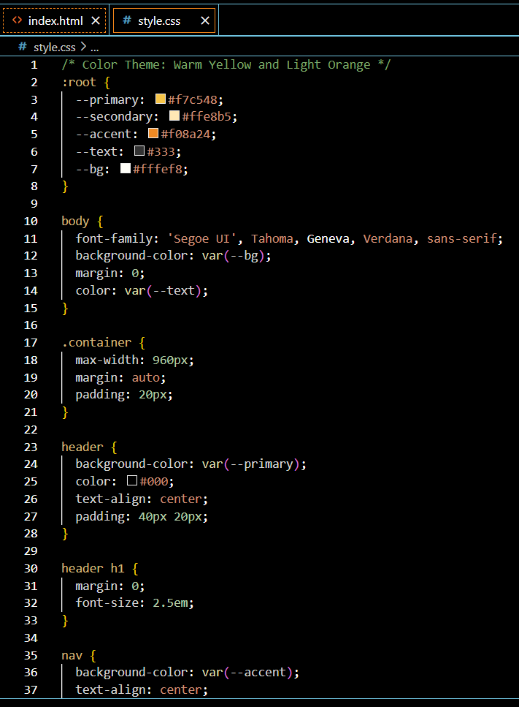

**Figure 4: CSS-code**

**(**Source: Acquired from VS-Code**)**

Its layout has a focus on clarity of orientation, grid-based positioning, and topics-based navigation in order to provide a pleasant user interface.

* ***LaTeX:*** A professional and typeset CV and report was created using LaTeX. To find a proper class, formal and clean appearing, which may be used in academia and industry, moderncv class was selected. LaTeX allowed optimal formatting and production of high quality documents, which could not be conveniently created with the traditional word processor. it is also available in the site as a downloadable in .pdf format- CV.
* ***Git/ GitHub:*** The version control was performed with the help of Git that provided an opportunity to make a structured commit, changed tracking, and rollback functionality during the development. GitHub was used as the version control hosting site as well as deployment site through GitHub pages. Putting the repository in connection with GitHub Pages can update the site when pushing the changes in the main branch, allowing the site to be efficiently delivered.
* ***Code Visual Studio (VS Code):*** The full portfolio was constructed with Visual Studio Code which is a feature rich and lightweight integrated development environment. It provided smooth workflow to write, edit, and manage documents and code through HTML, CSS and LaTeX integration and support of Git.
* ***Sequel Technologies and Extensions:*** Although the existing version is not dynamic, it can be enhanced later with the help of JavaScript, adding an element of interactivity to it, e.g., introducing a contact form or a switcher of themes. Moreover, Tailwind CSS, can be used to make it responsive.

# Challenges and Problem Solving

***LaTeX Curriculum Vitae***

Formatting the CV with LaTeX was one of the first problems Harpreet Singh was encountering. LaTeX capitalized on a markup approach so changing its styling including font sizes, spaces, and sectioning had a learning curve. Uniformity in content in different sections and modification of default moderncv template required further time and trial and error. Such problems were addressed with the iterative testing and with referencing to the official documentation and also to the community forums.

***The Web Site Web Layout and Alignment***

Creating an appealing clean and responsive layout with HTML and CSS alone was challenging in some way (Maurice, 2022). Positioning of various elements such as the navigation bar and ensuring great spacing when different screen sizes were used had to be worked through manually through the tuning of the CSS without using a front-end framework. CSS grid system was developed to handle the skills section in a more efficient way and paddings/ margins have been changed to achieve uniform alignment.

***Fixes and Issues in Deployment Bug Fixes***

Small issues were met with during development, like the variable font size, conflicts in link styling, and floating issues. Also, injecting the site to GitHub Pages would result in some set-backs initially when the CSS styles would not load correctly (Ranjan *et al.,* 2020). This was attributed to improper file paths that were rectified by making all the reference relative and the files enclosed in the root directory.

***Responsiveness Adjustments***

The site may not be fully responsive in all gadgets but some efforts were made to enhance readability in typical screen displays with a central container and a scalable font. Future optimizations beyond mobile responsiveness The next step to be made is to fully respond to mobile media queries.

These experiences in problem-solving assisted in the better realization of front-end development and version control.

# Reflection on Strengths and Weaknesses

***Strengths***

A strength of my portfolio is its readability and clarity. When designing the website, I focused on clear and simple design to achieve a more usable site. I was able to maintain clear organization of all content while avoiding unnecessary clutter. The minimal layout showcases the content in accessible, ecumenical ways which is appropriate when thinking about a professional context and looking at technical portfolio expectations.

Another strength is how light and accessible the website is for users. The website is only using HTML and CSS so many browsers can leverage the website for fast loading and acceptable performance on traditional desktop and tablet devices. Since the structure is modular, separating content from styling, it is easy to keep maintenance and implement updates as future work is produced.

Another critical element I utilized to its fullest was version control. Utilizing Git, each major change was committed with an identifiable message that tracked progress. I understood how to revert back and, if different efforts made little difference, to eliminate changes. Hosting through GitHub Pages, I also had the benefits of transparency and valuable hands-on experience with repository management.

***Weaknesses***

However, despite its strengths, I would classify the current portfolio as non-interactive. To date, I do not have any JavaScript related elements, e.g., dynamic contact forms, interactive project showcases, etc. While the ability to provide interactive web elements is much better developed, I am limited to just providing a ship-free floating static blog display.

Another limitation is I do not provide animations or transitions which would increase overall value by improving visual design and user experience. Moreover, the site is only somewhat adaptable; it fits medium-sized screens fairly well, but it still needs improvements for mobile and smaller displays.

These issues present some opportunities for technical growth in front-end development down the line.

# Future Improvements

***Project Gallery***

In my future iterations of the website, I plan to create a project gallery to emphasize my technical body of work. Each project can have the ability to be filtered by the technologies used and/or in terms of type of project. This can allow the audience to identify and explore different types of relevant content.

***Interactive Contact Form***

In order to facilitate this interaction as well, I can implement a contact form powered by JavaScript. This can enable a visitor to send a message directly from the website and allow them to be able to send a message quicker and easier.

***Mobile Responsiveness:***

The layout of the portfolio is [kind of] responsive to a point, and so a big improvement to make can be that it is fully mobile-responsive (Lee *et al.,* 2020). I would like to use media queries and responsive units in order to optimize viewing experiences on screens of all sizes. Especially mobile devices and tablets.

***Technical Blog Section:***

I also plan to add a blog or articles section of some capacity, to provide my thoughts on programming, development practices, and/or developing technologies. This would showcase my writing ability, and technical curiosity.

***Modern Frontend Tools:***

To improve the website in terms of efficiency, design and maintainability more so, I can consider adding modern frontend tools, such as Bootstrap or Tailwind CSS. And, I may leveraging a modern, react-based framework to organize the site in a modular way, for scalability.

Given all of these improvements, there are further aspects that would enhance not only the functionality of the website but ultimately the professional value of the content.

# Conclusion

In developing this portfolio, Harpreet Singh created a well-organized professional digital presence that incorporates his academic history, technical skills, work experience and a CV built in LaTeX. The portfolio demonstrates his ability to design and publish a clean, functional website to industry standards.

Learning Outcomes: This project created an excellent experience with front-end web development, LaTeX typesetting, and version control using Git and GitHub. This also furthered his understanding of coding organization methods, deployment workflows, and the importance of documentation.

Career Readiness: This portfolio makes Harpreet a career-ready candidate who now has a way to present his technical profile in a professional and accessible format. The tech industry is increasingly competitive and high-tech employers expect job applicants to have a digital footprint. This project is a significant first step in developing his personal brand and develops the foundation for future work in software development and computer science.

# Reference Lists

Gauthier, L., 2020. Overview of Loan Portfolio Analysis. In Securitization Economics: Deconstructing the Economic Foundations of Asset Securitization (pp. 35-81). Cham: Springer International Publishing.

Gaver, W. and Boucher, A., 2024. Designing with data: an annotated portfolio. ACM Transactions on Computer-Human Interaction, 31(6), pp.1-25.

Maurice, F., 2022. HTML & CSS für dummies. John Wiley & Sons. doi-https://books.google.com/books?hl=en&lr=&id=R4aJEAAAQBAJ&oi=fnd&pg=PT7&dq=HTML+and+CSS&ots=gZ6ho5Q4W2&sig=eMzvIp4py1jdZz8n_VpFI2bzzfg

Ranjan, A., Sinha, A. and Battewad, R., 2020. JavaScript for modern web development: building a web application using HTML, CSS, and JavaScript. BPB Publications.

Lee, Y.W., Ceylan, H., Yasa, I.C., Kilic, U. and Sitti, M., 2020. 3D-printed multi-stimuli-responsive mobile micromachines. ACS applied materials & interfaces, 13(11), pp.12759-12766.